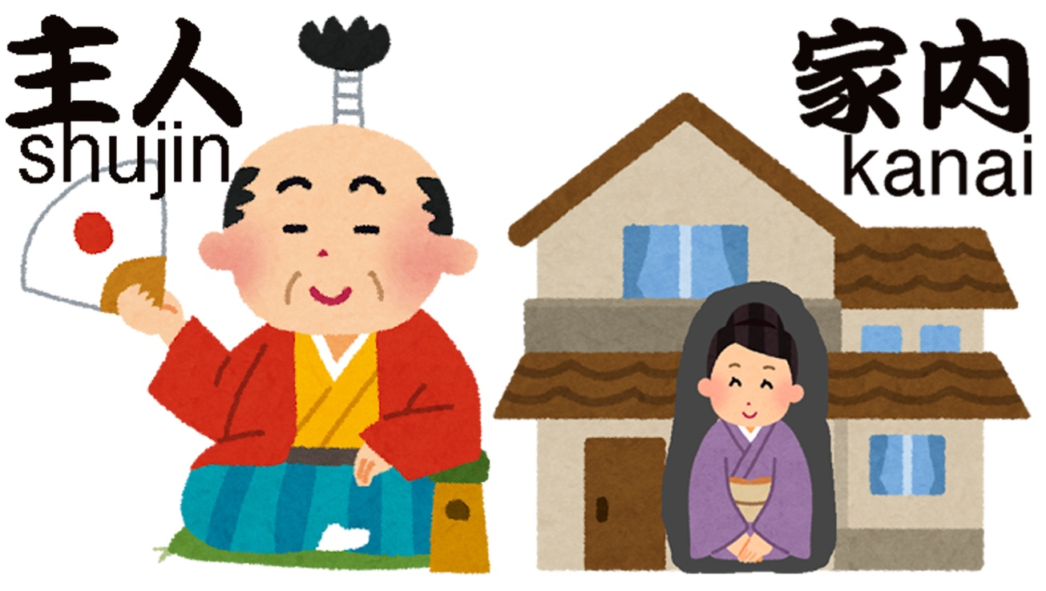
Even John Lennon and Yoko Ono naturally used the Japanese terms ‘shujin’ and ‘kanai,’ as shown in Lennon’s 1979 illustration KAZOKU (Family).
The male-centric Japanese spousal terms, ‘shujin’ and ‘kanai’ are still widely used in Japan today. Why?
Kenji: Hey, Emily. I found an illustration drawn by John Lennon on a website. In it, John and Yoko refer to each other using the Japanese terms “shujin” and “kanai.”
Emily: Really, Kenji? But those are just Japanese words for “husband” and “wife,” right? John lived in Japan for a while and even studied Japanese, didn’t he?
Kenji: Well, it’s actually more complicated than that. The word shujin is written with the Chinese characters 主人. The first character, 主, means “primary” or “master,” and 人 means “person.” So together, shujin literally means “master.”
Emily: Then what about kanai?
Kenji: Kanai is made up of the characters 家 and 内, which literally mean “inside the house.” In other words, it refers to “the person who stays in the house.” So shujin and kanai are not simply neutral words for husband and wife. Traditionally, they reflect an East Asian patriarchal view of marriage — the “master of the house” and the person who stays inside doing household work. It’s almost like “lord” and “housemaid.”
Emily: Wow. It is surprising that John and Yoko used such male-centered terms so naturally. But John lived in Japan in the 1970s, right? That was more than half a century ago.
Kenji: Surprisingly, though, shujin and kanai are still widely used in Japan today. This contrasts with China, which shares a similar East Asian cultural background but now commonly uses more neutral terms like laogong and laopo.
Emily: Why haven’t the Japanese terms changed?
Kenji: That’s exactly what this study investigated. A Chinese linguist, Nin, and a Japanese psychologist, Mori, used a paper-and-pencil Implicit Association Test to measure the automatic processing speed of the terms shujin and kanai, and compared them with more neutral Japanese spousal terms such as otto and tsuma. Surprisingly, there was very little difference between them. The researchers concluded that shujin and kanai have largely lost their original literal meanings and are now processed almost the same way as ordinary words for husband and wife in everyday automatic language use.
Emily: That sounds encouraging. So, the male-centered bias has finally disappeared?
Kenji: Unfortunately, not completely. The study also found that while the bias had largely disappeared among female students, male students still showed similarly strong male-centered associations for both the traditional and the neutral terms.
Emily: So simply replacing words doesn’t necessarily eliminate the underlying bias.

Article Information: Nin, R. & Mori, K. Are Japanese spousal terms as gender-biased as they seem? An examination using implicit association measures. Published in PLoS ONE on June 3rd, 2026. https://doi.org/10.1371/journal.pone.0330816
Contact Information: Kazuo Mori, Ph.D., Professor Emeritus, Tokyo University of Agriculture and Technology [ kaz@mori.cc.tuat.ac.jp ]

